- Software Requirements: Functional, Non-functional , User , System requirement
- Fact finding techniques: Interviews, Questionnaire, Record reviews and Observation
- Analysis and Design Tools:
- Flow charting
- Decision tables
- Decision Trees
- Structured English
- Structure charting Techniques
*************************************************************************************
- Software Requirements:
Software requirement is a process of defining expectations of the users from the software system. After collected all the requirements, system to be developed.
These system requirements are classified in functional requirements and non-functional requirements.

- Functional Requirements - Functional requirements defines the functions. It has to be performed, the software product. How system worked on accepting inputs from the user, and produces the desired output.
- Example: Pizza delivery app providing following functional requirement including
1. Customer should be able to select pizza and add them to cart.
2. Customer should be able to select delivery and pick up option
3. The app should show the estimated delivery

- Non-functional Requirements – Nonfunctional requirements are like the qualities or characteristics of software product. They don’t necessary what the software does but they talk about how well it does it. Nonfunctional requirements aspect like maintainability, portability, usability, reliability.
- Example- continue as pizza delivery app.
- 1. The app should be fast and responsive, loading quickly when opened.
- 2. It should be easy to use and navigate even when people who are not teach
- 3. The app should be secure so customer’s payment information secured.
- User Requirements: It defines expectation of customer.
- What type of input and output requirements of the user?
- It also includes source, formats, contents, etc.
- User requirements are defined: 1. Attractive 2. Simple to use 3. clear to understand
System Requirement: System Requirement is a specific and detailed description of what a software application or a technical system needs to do. These requirements provide the functionalities behaviors and technical specification. It ensures that resulting software or system works as intended and fulfills their purpose. They help the software can functions within the desired technical environment.
Example- Playing a game on computer system or phone it has requirement of at least 4 GB RAM and Graphics card

- Fact finding techniques
It is very difficult to collect information from large and complex organizations. So analyst make a clear plan to collect information.
Fact finding techniques means it is A specific method used for finding information of the system are called fact finding techniques. The analyst can be use multiple techniques for investigation.
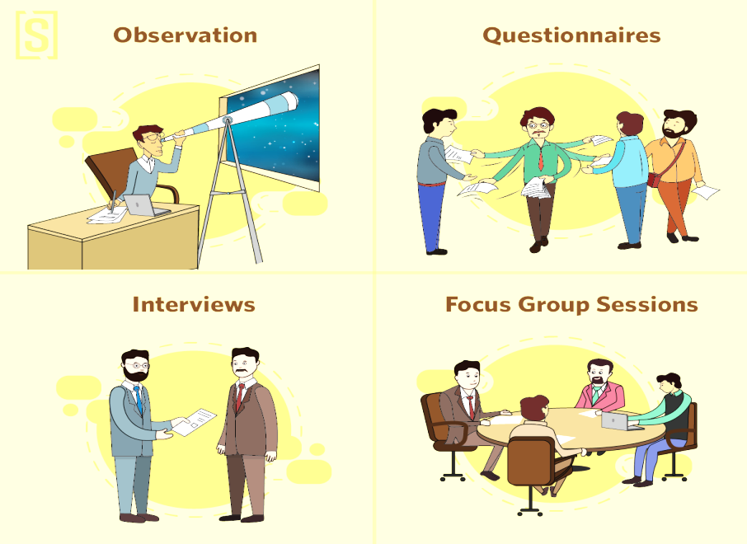
Fact gathering techniques are:
1. Interview
2. Questionnaire
3. Record review
4. Observation

1. Interview-
In interview technique, analyst collects information about the current working systems form face-to-face interviews with persons or groups of users. The purpose of interview technique is to find and verify facts, identify requirements, gather ideas, suggestions and existing problems etc. In this technique good communication skills required for interaction between analyst and user. The analyst is also observe body language of interviewee (Users).
Types of interview –
Structured Interview | Unstructured Interview
Fixed type of questions are asked | Different type of questions are asked
Simple to manage | Not simple to manage
Specific information is collected | Possibility of unnecessary information
Interview period is short | No limit on interview period
Lot of study & preparation is required | No such preparation is required
- Advantages -
- More accurate and reliable information is collected.
- Interviewer modify questions during interview.
- Interviewer observe interviewee’s body language.

- Disadvantages -
- Time consuming and costly
- Requires highly skilled interviewer

2. Questionnaire -Questionnaire technique is a structured and formal method of collecting data. It is not possible to conduct interviews of all the users. In such cases, system analyst use questionnaire. This method taking information from the person in written format.
There are two types of questions-
- Open ended questions (free-format): Questions are given without any choice of answers. User has to write the answers in own words on the given space.
- Closed ended questions (fixed-format): Questions are given with choice of answers for each question and the user has just to mark the correct response. Closed ended questions have fixed responses such as following types:
- Fill In the blanks questions- gives specific information. Responses can be statistically analyzed.
- Yes/No type questions- Answered by yes or no, otherwise I don't know.
- Multiple choice questions- Select specific options for an answers. Advantage is faster tabulation and less analyst bias.
- Rating scales questions response is given a range of 1-5.

- Advantages of questionnaires
- Large amounts of information can be collected in a short period of time.
- Less expensive than interview technique.
- Time saving as compared to other techniques.

- Disadvantages of questionnaires
- Asking only limited amount of questions without explanation.
- Difficult to design questionnaire format.
3. Record Review – In this type the Information related to system is already available in some type of documents, records and files (like system user manual, system review/audit, brochures etc.). That information and documents examined by analyst. That documents provides a valuable information about the system.
It is carried out by the systems analyst in the following steps:
- First, the analyst visits the concerned department and meet the managers and users.
- Examines each and every document to understand the working of the system.
- Enquiry of various users about the documents they maintained.
- Prepares the complete list of documents that are relevant to the current and proposed system.
- In the last, the analyst collects the copies of all the relevant documents.

4. Observation -Observations are one of the most effective tools for analyst where an analyst personally goes to the site and learns the functioning of the system.
Analyst visits the organization, observes and understand the flow of documents, working of the existing system. This is a highly successful technique, because developers have the chance of experiencing the current system.
Advantages
- Observer can see exactly what is being done
- Observer can also obtain data describing the physical environment of the task
- Observer can do work measurement
- Disadvantages
- Operations run less smoothly because people might be nervous during observation.
- May wrongly observing certain tasks.
- Time consuming

- Analysis and Design Tools:
System Analysis and Design is used various tools for representing complex processes and procedures that involved in system. Using some analysis & design tools i.e. Flowcharts, Decision Tables, Decision Trees and Structure charting Techniques.

- Flowcharts
A flowchart consists a set of ‘symbols’ which is connected by arrows. In flowchart, boxes are used to represent different operations and the arrows are used to represent the sequence of these operations. The purpose of flowchart is graphically represent logical flow of data in the system.

- Draw Flowchart of Sum of two nos.
- Draw flowchart of Average of two nos.
- Draw flowchart of college Admission process.
- Symbols used in a flow charts:
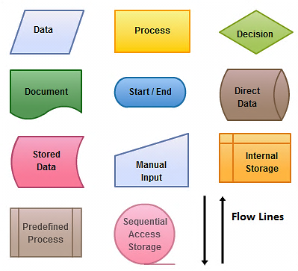

General guidelines to prepare Flowcharts:
- Listing all requirements in proper logical order in detail.
- Use suitable standard flowcharting symbols and templates.
- Avoid cross lines
- Use connectors to reduce the number of flow lines.
- Advantages of flowcharts:
- Excellent way of communicating logic of a program.
- Problem can be analyzed in more effectively.
- Flowchart makes program or system maintenance easier.
- It helps the programmer to write the program code into any programming language.
- Disadvantages of Flowcharts:
- Drawing flowchart is a time-consuming task.
- Difficult to alter or redraw the flowchart.
- It requires special tools to draw the necessary symbols.

Decision tables:
Decision Table represents conditions and actions in a tabular format that is Rows and Column.
Decision table is divided into two parts:
- Condition
- Action

- Condition: In this type it shows and specifies all conditions that are applied to the input data. It is also divided into two parts-
- Condition Stub – It shows the various possible conditions exist in given data.
- Condition Entry - all possibilities of yes and no answers related to the condition stub.

- Action: The action part is subdivided into two parts-
- Action Stub - shows the various actions taken against different conditions.
- Action Entry - is used to find out which action is taken corresponding to a particular set of conditions. (X)or( ): action Applicable, Dash (-): action Not Applicable. Physical layout of decision table is as follows.

Creating Decision Table
- Identify all possible conditions.
- Determine actions for identified all conditions
- Create Maximum possible rules.
Determine the rules in a decision table by the formula:
Number of rules = 2^{N} Here N represents the number of condition.
A decision table with four conditions has 16 Rules. (2⁴ = 2 x 2 x 2 x 2 = 16) and rules with six conditions has 64 rules and eight conditions yield 256 rules.
Examples: For 2 conditions there are 2²=4 possible combinations.
Condition 1 | Y | Y | N | N
Condition 2 | Y | N | Y | N

CASE 1: Consider case of a bank which grants loan to the customer under the following conditions-
1) If a customer has an account with the bank and has no previous loan outstanding, the loan will be granted.
2) If a customer has an account with the bank but some amount is outstanding from previous loans then new proposal’s loan will be granted if special management approval is there.
3) In all other situations loan applications are rejected.
Draw decision table:
Step- 1: List of conditions and Actions
Condition: 1. Customer has an account.  2. No previous loan outstanding  3. Customer has management approval. | Action : 1.Grant loans  2. Reject loans.

Step-2: Combine conditions which describe two possibilities of a single condition.
Rules | Condition | Action
1 | Customer has account and no dues from pervious loan | Grant Loan Application
2 | Customer has account and some dues from pervious loan. He has management approval | Grant Loan Application
3 | Customer has account and some dues from pervious loan. He has no management approval | Reject Loan Application
4 | Customer has no account | Reject Loan Application

Header | Decision Table | Rule 1 | Rule 2 | Rule 3 | Rule 4
CS | Condition1: Customer has Bank A/C | Y | Y | Y | N
 | Condition2: Customer has no dues | Y | N | N | -
 | Condition3: Customer has mgt. approval | Y | Y | N | -
AS | Action 1: Grant Loan | X | X | - | -
 | Action 2: Reject Loan Application | - | - | X | X
Y: Yes, N: No and X: Applicable, -: Not Applicable

- Advantages of Decision Tables:
- Decision rules are clearly structured
- Documentation is easily prepared, changed or updated
- Easy to use
- Enable more compact documentation
- Easy to understand by non-computer users and managers

- Disadvantages of Decision Tables:
- Does not show the flow
- Cannot list all the alternatives
- Not easy to translate it

- Decision Tree
Decision tree is a tree like structure that represents the various conditions and the subsequent possible actions.

Decision Tree is tool for documenting procedures where actions needs to be taken
Depending on a number of conditions. This method show the relationship of each condition & it’s allowed actions.
The root is on the left side and the actions are shown at the right side Decision tree start from the root (starting point of the decision sequence) and proceed towards the various possible nodes and sub nodes. The size of the tree will depend upon the number of conditions and actions. Each condition is express in two ways, namely T/F or Y/N.
This decision tree representation form is very beneficial to the analyst for show all the given condition in a logical format
Example: Consider case of a bank which grants loan to the customer under the following conditions-
1) If a customer has an account with the bank and has no previous loan outstanding, the loan will be granted.
2)If a customer has an account with the bank but some amount is outstanding from previous loans then new proposal’s loan will be granted if special management approval is there.
3) In all other situations loan applications are rejected Draw Decision Tree and Table?
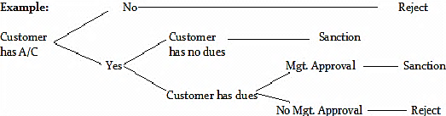

Draw decision table:
Step- 1: List of conditions and Actions
Condition: 1. Customer has an account.  2. No previous loan outstanding  3. Customer has management approval. | Action : 1.Grant loans  2. Reject loans.

Step-2: Combine conditions which describe two possibilities of a single condition.
Rules | Condition |  |  |  | Action
1 | Customer has account and no dues from pervious loan |  |  |  | Grant Loan Application
2 | Customer has account and some dues from pervious loan. He has management approval |  |  |  | Grant Loan Application
3 | Customer has account and some dues from pervious loan. He has no management approval |  |  |  | Reject Loan Application
4 | Customer has no account |  |  |  | Reject Loan Application
Header |  | Decision Table | Rule 1 | Rule 2 |  | Rule 3 | Rule 4
CS |  | Condition1: Customer has Bank A/C | Y/T | Y/T |  | Y/T | N/F
 |  | Condition2: Customer has no dues | Y/T | N/F |  | N/F | -
 |  | Condition3: Customer has mgt. approval | Y/T | Y/T |  | N/F | -
AS |  | Action 1: Grant Loan | X | X |  | - | -
 |  | Action 2: Reject Loan Application | - | - |  | X | X
Y:Yes, N:No and X:Applicable, -:Not Applicable

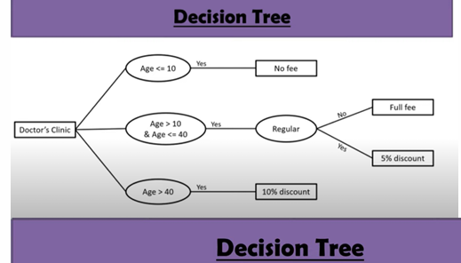

Advantages of Decision Tree:
- It expresses the logic of ‘if then else’ in pictorial form, showing conditions & actions.
- Outcome of another decision.
- It helps the analyst to identify the actual decision to be made.
- It is used to verify problems that involve a few complex decision and limited actions.
- Disadvantages of Decision Tree:
- The lack of decision tree, absence of information in its format to take what other combinations of conditions to test.
- A large number of branches with many paths will confuse rather than help in analysis.
Structured English: Structured English is similar to programming language such as Pascal.
It does not have strict syntax programming rules.
It provides the precise description of process.
The structured English should be understandable to the user.
Example-
Conditional statement If -Then
BEGIN IF
IF Customer age > 65
THEN Billing Rate= Senior Citizen Rate
ELSE Billing Rate =Standard Rate
END IF
If customer pays advance
Then
Give 5 % Discount
Else
If purchase amount >=10,000
Then
If the customer is a regular customer, then give 5% discount
else no discount
end if
else no discount
end if
end if
Structure Chart: Structure Chart are designing tools for Describing the system according to functions. It describes the software architecture.it is a next step of DFD.Structured chart consists of rectangular boxes that represents the modules connecting arrows and lines.
Symbols in structured chart:
1) Module: It represents process or task of system
2) Loop: It represents repeated execution of a module. A curved arrow represents loop in the module.
3) Conditional call: It represent that the control module can selects any of its sub modules based on some condition.
4) Data Flow: It represents flow of data in the modules
5) Control Flow: It represents flow of control in the module.

